1. We've posed the general problem of supervised regression learning and introduced two algorithms that can solve it. Linear regression creates parametrize models and K and N is a non-parametric instance base method. There are in fact many algorithms that can solve this problem. Each algorithm has it's on pros and cons. In this lesson we'll look at various methods for assessing those algorithms.

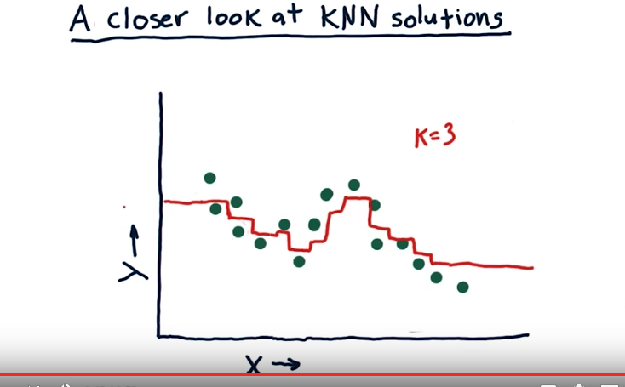
2. As we begin now looking at how to evaluate various machine learning algorithms, let's start back with KNN and look a little more closely at the sorts of solutions it provides. Let's start with our training data, and remember we've got pairs of X and Y, so each one of these dots represents one training tuple. And I'm just making this data up, of course. But suppose we were going to query this KNN model over in this region. Say right here at this point. Well, the nearest three. Let's use K=3 here. The nearest three are going to be these. And remember, we take the mean of their value to get the value at that query point. So if we query from here all the way to about here, our model is going to take the mean y value of those, so the output of our model is going to look something like this. And notice it gives the same value at all these points. Eventually, as we query from left to right, we get to a point where this one gets dropped out, and this one gets added in. And at that point we'll have a sudden drop about like that in the model. And we continue on like this. We'll have another drop like that. If we query our model now from left to right in very, very tiny increments we'll get the result that looks something like this. Note that indeed there are sort of jump points here. Some nice things about this are that it's not over fitting the data. In other words, it's not tagging each point. A negative aspect though is at the ends there we have these horizontal lines that are no longer changing or essentially this model is not able to extrapolate like we might if we had a parametric model.

3. Let's consider now what happens to the model that comes out when we change the value of k. So we've got three k nearest neighbor models here. Each one is using a different value of k, and I want you to match the value of k to the output model here. Okay, so I want you to look at these different charts. Each one of these models shown in red is using a different value of k. So I want you to fill in these little boxes, which chart corresponds to the value of k. So one of these charts was created with k=1, one was created with k=3, and another was created with k=N, where N is the total number of elements in the dataset. And there's another question I want you to answer. True or false, as we increase k we are more likely to overfit. I haven't told you yet in too much detail what overfitting is. Let me just give you a quick gist of it so you can answer the question. An overfit model strives really hard to match the dataset exactly. And then when we go on later to use new data or test it with test data, it tends not to do so well. So go for these two questions and I'll come back in a minute and tell you the answer.

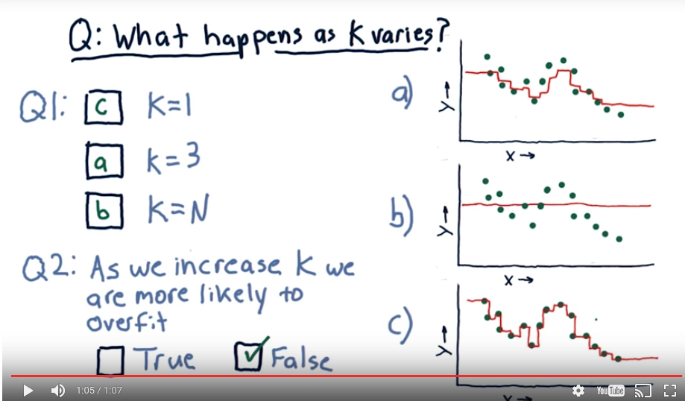
4. Alright, let's start with this one. One of these models was created with k=N, and it's this one. If we use all of the neighbors and all the data points, and take their average, the value of our model will be the same at every single point. Namely the mean of all the Y's of all the data points. So this one is b, as in bravo. Let's do this one next, K=1. We know that this model is going to tag each point exactly, because, when we're at that data point, we'll have exactly that value. So this model steps up and down and tags each individual point exactly. So that's a C, and this is, this one is K=3, which we already looked at, A. Okay this next question, as we increase k we are more likely to overfit, that is false. In K and N, if K is equal to one, will have the most overfit model. And as we increase K, we're less and less likely to overfit as we go forward.

5. Let's consider now a similar question, but now we're using parametric models, a polynomial model of degree d. Real quick, here's what we mean when we say polynomial of degree d. So here's what our polynomial model looks like, it's m1 times x, m2 times x squared, m3 times x cubed plus b. This is a third order polynomial, or a polynomial of degree d so I want you to consider d=1, d=2, d=3 and I want you to select which model over here goes with that degree. Then I want you to consider this question. True or false, as we increase d we are more likely to overfit.

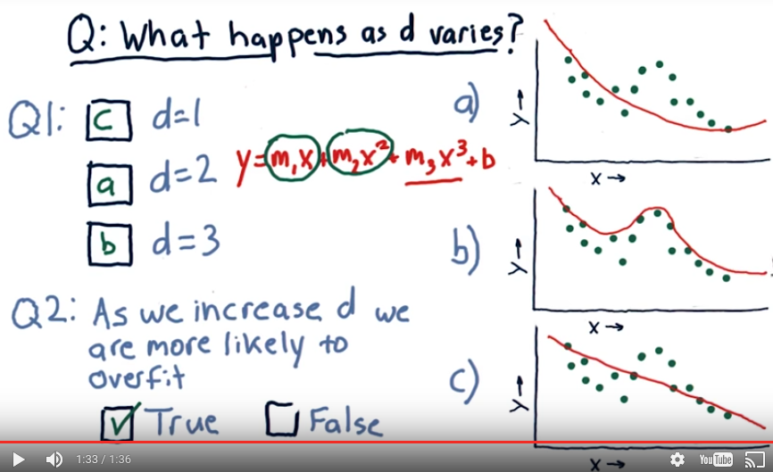
6. Okay, let's start with d=1. Well, that's a linear model. That includes just this component. So of course, it must be a line, so it's gotta be this one. That means the answer here is c. Now we have order two and order three to choose from. Two is a parabola, so it's including this component as well. This one's a parabola of course. And so the answer to that one is a. And finally that leaves only b, but let's look at why that is. When we have a cubed component, we can get this additional curl in there. Now as you notice, as we increase from order one to order two to order three, we're gradually getting closer and closer to tagging the actual data. So we get to this question, as we increase d we are more likely to overfit. That is true. And in fact, it can be shown with a polynomial like this that as the order of the polynomial or d reaches in, the total number of points, we actually can match the data at every point. Now a couple things to note here. One is as we go off the edge here for all these models, we're able to extrapolate in the direction the data seem to be going. And this is capability that parametric models or these polynomial models have that KNN does not.

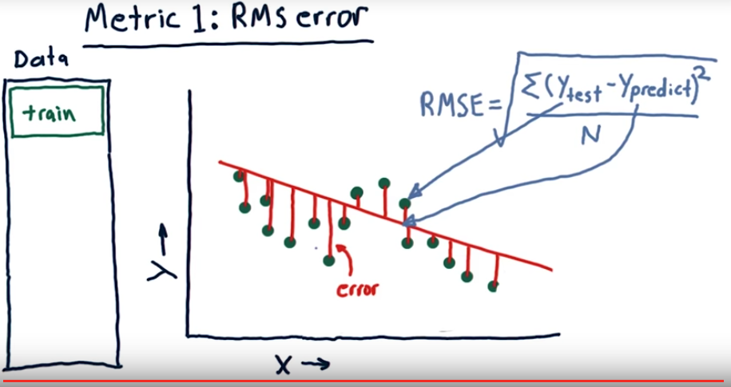
7. I've shown you some graphs that suggest the ways the models can fit the data, more or less closely. But let's have a more formal definition of this matching. It's called error. A standard way to measure error, is called RMS error. Let me show you how to calculate this. Let's suppose we use this data, which are these green points, to build a model. Let's say it's a linear model like this. We can assess the model at each real data point. For instance, at this data point. And measure the difference between the Y value of the data point, and the model. And this difference is error. Now, we've got an error at every single one of these data points. And what we do to measure root mean squared error, is to take the error at each one of these points, square it, add them together, take the average, and take the square root of that. So that sounds kind of complicated, but here's what it looks like. Ytest minus Ypredict. So Ytest are the actual values of the data. Ypredict are what our model predicted. We take that difference at each point. That's this difference. Square it, sum all those together, divide by the number of points and take the square root. And that's our root mean squared error. And what this is an approximation of really, is sort of the average error here. But we end up emphasizing larger errors a bit more.

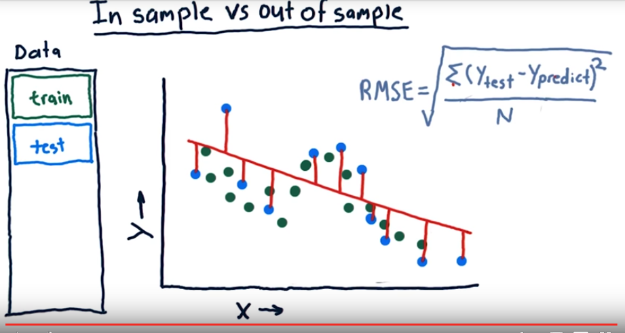
8. Now, we just measured the error of this linear model against our original training data. We know, though, from say, k and n, that we can build models that can fit this training data exactly. So we can have arbitrarily small error against our training set. The more important measure is, what is our error out of sample? So, what out of sample means is we train on our training set, but we test on a separate testing set of data. And, that's going to be different than our training set. So, to measure out of sample error, we look at the error from our testing set, not our training set. So we look at each one of these test points and measure the error for each one of those. So we look at these blue points instead of the green points, plug them into this equation just like before, and that's our out of sample root mean squared error.

9. Suppose we're measuring the error of a model that you built. Which sort of error would you expect to be larger? In sample error, in which we measure the accuracy of our model against the set it was trained on? Or out of sample error, where we measure the error of the model against a new test set that it hasn't seen before? Which is worse?

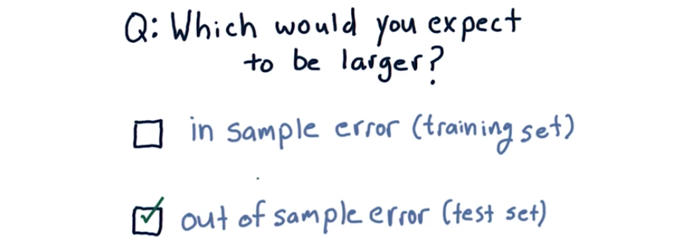
10. In general, in fact in almost every case I know of, out of sample error is always worse than in sample error.

11. Usually when researchers are evaluating a learning algorithm, they split their data into two chucks. The training chunk, and a testing chunk. Training usually is about 60% of the data, and testing is about 40%. Now if you train and then test on that data, that's one trial and in many cases that's enough, you measured your root means square error and that's an assessment of your algorithm. You might compare it against another algorithm. But one problem researchers sometimes encounter is they don't have enough data to effectively analyze their algorithm. One thing they can do is effectively create more data by slicing it up and running more trials. Here's how that works. So what we can do is we can slice our data into say five different chunks, and then we can train here on 80% of the data, and test on 20%. That's one trial. Then we can switch things up and train on this 80% of the data. And test on that, that's another trial, and so on. I'm sure you see how this is going. We can effectively get five different trials out of this one set of data.

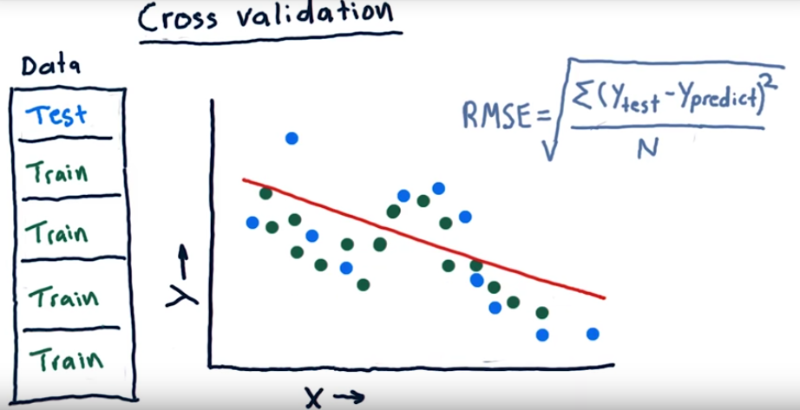
12. Cross validation is a great tool, but the typical usage of it doesn't fit financial data applications well. The reason is that it can permit peeking into the future. So for instance, if our training data is after our test data that means we're seeing the future ahead of our test. Any sort of peeking like this can read to unrealistically optimistic results, so with this sort of data we need to avoid it.

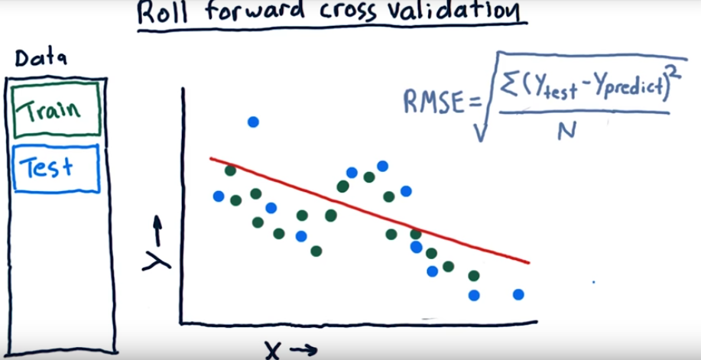
One way to avoid this problem is with role forward cross validation. That means our training data is always before our testing data. But we can still have multiple trials just by rolling our data forward, like this and this and this, till we run out of data.

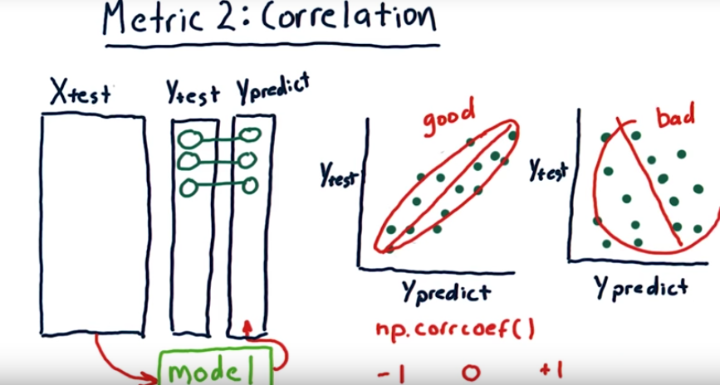

13. Another way to visualize and evaluate the accuracy of a regression algorithm is to look at the relationship between predicted and actual values of our dependant variable Y. Here's what I mean, query our model, the one that we trained on training data with Xtest, our testing data set. The output of that query is a new vector of Y values, Ypredict. So based on this Xtest data our model predicts this Ypredict data. We can now compare what we know to be the correct, or true, data and Ytest with what our prediction was. So this pair would appear somewhere on this chart, say here. So its a value along the horizontal access here is what the prediction was and along the vertical axis was what the ground truth is. So we can plot these pairs all the way through our data. Now, if this scatterplot is arranged in approximately a nice line like this, that means we've got a pretty good prediction algorithm. On the other hand, if they're not aligned so well and they look sort of like a shotgun blast, our learner is not so good. We can measure this property quantitatively using something called correlation. You can use the num pi function corrcoef to measure the correlation between Ytest and Ypredict. You'll get an answer somewhere between -1 and +1. Where +1 means they're strongly correlated, -1 means they're inversely correlated, and 0 means there's essentially no correlation at all between them. One thing to point out here is that correlation isn't the slope of this line. Lots of people think that's what it is. Correlation has to do with how well aligned the points are with the line that we fit. So if it's a nice oval that fits close to that line, we usually have a high correlation. If it's a big round thing we've got poor correlation.

14. I want you to think now about the relationship between RMS error and correlation. And in particular, I'm talking about correlation between our predicted result and the actual result. Do you think that as RMS error increases, correlation would decrease, correlation would increase, or we can't really be sure?

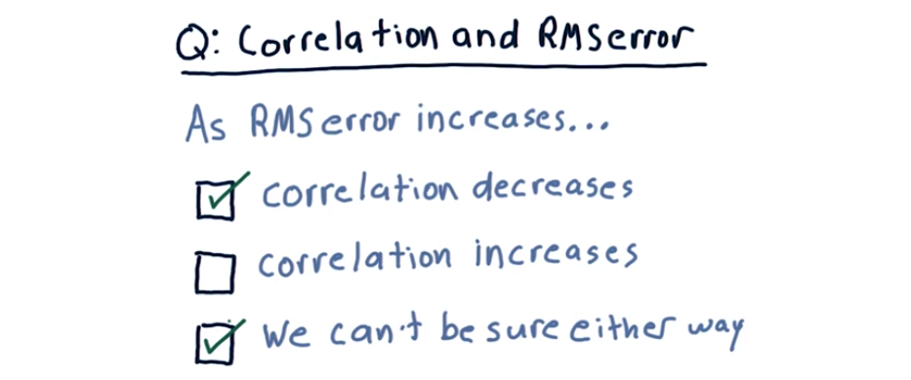
15. So in most cases, in fact almost all cases, as RMS error increases, correlation decreases. So this would be a reasonably correct answer. But it is possible to construct examples where as RMS error increases, correlation might increase. So that also lets you have it correct if you checked we can't be sure either way.

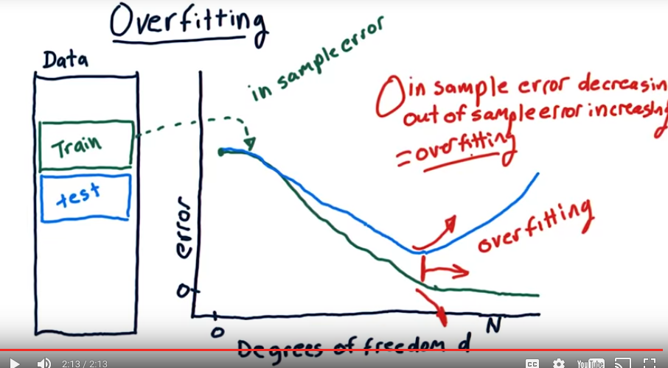
16. I've mentioned overfitting before, but I haven't yet defined it. Before we could define it, and I could give you an example, we needed to have a definition of error. Let me now show you what I mean. Let's consider parameterized polynomial models where we can, one at a time, add additional factors, like x, x squared, x cubed, x to the fourth, and so on. Let's create a graph where we have along the horizontal access degrees of freedom, or d, the degree of our polynomial. And vertically here, we'll have the error of our model. So let's measure error as we increase d on our training set. So when d is smallest, our error is greatest. And as we increase d, our error drops and drops and drops. In other words, we're fitting the data in sample better and better. When finally we get to N, where we have as many parameters in our model as we do have items in our data set, our error gets all the way down to zero. This is in sample error. Now, let's add a similar line for out of sample error. Remember that we expect our out of sample error to always be greater than or equal to in sample error. The curve will look something like this. It'll start out at maximum error, about the same as our in sample line, and as we go down, we begin to diverge like this. Now in this region both our in sample and out of sample errors are still decreasing, but eventually we'll reach a point where our out of sample begins to increase. In fact it may increase strongly. In this area, as we increase degrees of freedom, our in sample error is decreasing, but our out of sample error is increasing. And that's how we define overfitting. This is the region where overfitting is occurring. So, let me state that again. In sample error is decreasing, out of sample error is increasing. And we have those two together, it's over fitting.

17. I want you now to consider overfitting in KNN. So in this case our horizontal access will be K and it could range again from 1 out to N, the number of data points and then the vertical access will be error. I'm going to draw three charts here showing N sample error as a factor of K and out of sample error as a factor of K. And I want you to look at each one of them and consider which one of them you think is the proper representation of what that ought to look like for KNN. Which of these three charts correctly represents the shape that we would expect for out of sample error and in sample error for KNN, as K increases this way and error increases that way. So take a look and go ahead and fill in your answer over here.

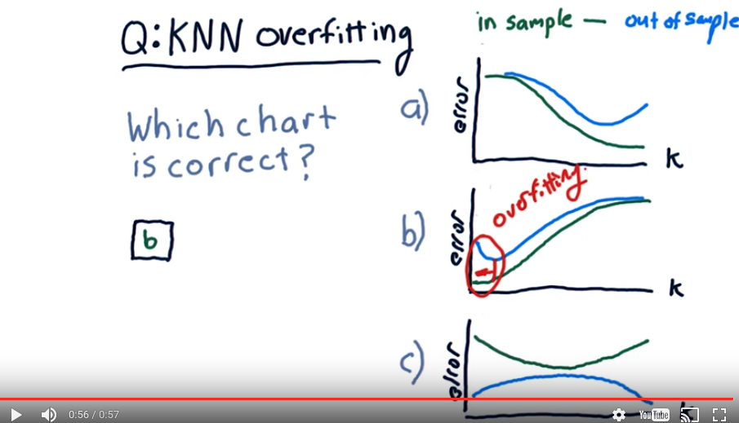
18. So the answer is b. This is a little bit tricky because the relationship for k and n and error is a little bit different than it is for polynomial degrees of freedom and error. Remember that as we reduce k down to 1 our in sample error approaches 0. In fact it becomes a 0 when k is equal to 1. And similarly as we decrease k, our other sample error decreases. But at some point it begins to increase. This one is wrong because as we increase k, our error increases. So this is not showing that relationship correctly. And this is just garbage that I threw in there to see if anybody would bite. [LAUGH] Now the region here in which overfitting is occurring is here, because remember, as out of sample error increases, and in sample error is decreasing, that's where overfitting occurs

19. There are a few other factors worth considering when evaluating a learning algorithm, and I've tallied a few of them here. I want you to think about each one of these and select which you think has better performance in that regard, linear regression or KNN. So let's step through them. How much memory do you need in your computer to save the model? How much compute time do you need to train the model? How long does it take to query the model? And finally, how easy is it to add new data to your model? So, again, I want you to check the box according to which one has better performance with regard to these factors.

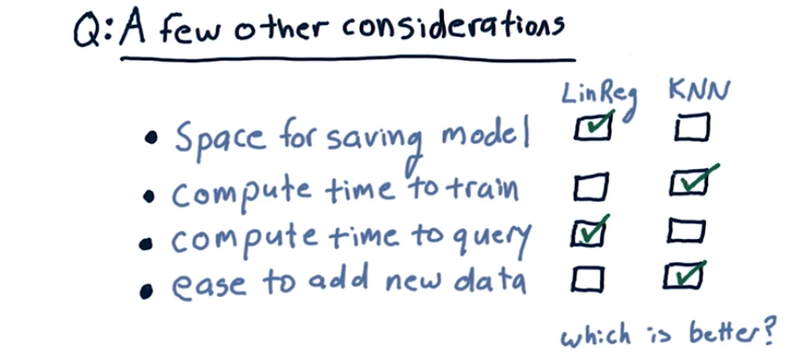
20. So, in terms of space for saving the model, linear regression is a hands down winner. For instance, if we're learning a third order polynomial, we have to only store four numbers. KNN, on the other hand, requires you to keep all the data, so it could be megabytes or gigabytes of data. So, KNN is bad in this regard. Compute time to train. KNN is much better in this case. In fact, it takes zero time to train KNN. You just stuff the model into a data store and you're done. On the other hand, linear regression has to take all that data, compute over it, to find those parameters. Compute time to query. LinReg wins hands down. All you do is you plug your X in, multiply it out and that's the answer. KNN requires quite a bit of time to query because you have to, among other things, usually do a sort to cross all the data. Ease to add new data. KNN wins that because all you gotta do is just plop it in there, you don't have to do any re-calculation. With linear regression, you have to add the new data and then recompute the factors. Well, that's all for how to assess learning algorithms. I will see you again soon. Thank you.

